1. The Volatility Smile:
   1. Using Black Scholes, options are priced under the assumption that assets follow geometric Brownian motion. This was accurately reflected in option pricing until 1987 when the market tanked 20% in two trading days.
   2. Now, option prices display a unique “volatility smile”; options are still priced using Black Scholes, but the implied volatility of the options change as the moneyness of the contract changes (see below). 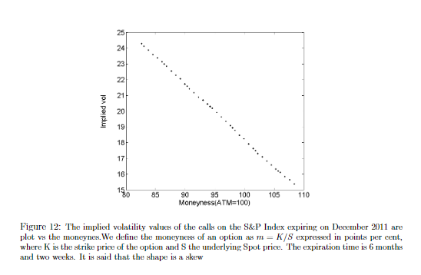
   3. Moneyness is defined as K/S\*
   4. The slope of the skew becomes greater as the expiration of the option shortens. 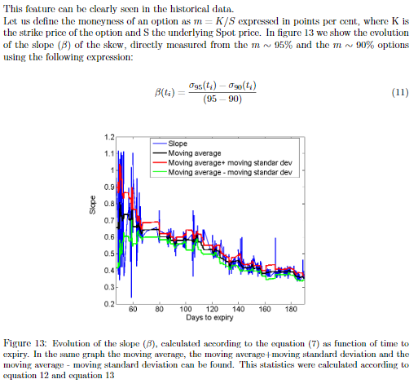
   5. There is a negative correlation between ATM implied volatility and underlying asset price.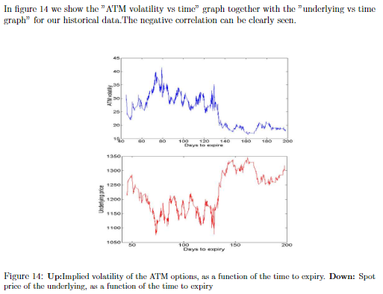
   6. After the market declines, the convexity of the volatility smile becomes positive, reflecting an anticipation of a market rebound. The IV of the OTM options does not seem to become greater than the IV of the ITM options, however.
2. Trading the Slope of the Volatility Smile:
   1. Daily changes in the slope of the volatility smile are mean-reverting.